**MINISTRY OF JUSTICE**

**Ministry of Justice**

MOJ Web & Mobile Application

Submitted By:

VERBANET TECHNOLOGIES L.L.C

**CONTENTS**

**1** **KEY DETAILS** 4

**2** **SCOPE OF WORK** 5

**3** **PROJECT SCOPE.** 6

3.1 PROPOSED SOLUTION MODEL 6

3.2 FUNCTIONAL REQUIREMENTS 7

**3.2.1** **WEB APPLICATION** 7

**3.2.2** **MOBILE APPLICATION** 8

3.3 NON-FUNCTIONAL REQUIREMENT (OTHERS) 9

3.4 PROPOSED SYSTEM ENVIRONMENT 10

3.5 TECHNICAL CONFIGURATIONS 11

**3.5.1** **DEVELOPMENT TOOLS** 11

**3.5.2** **RECOMMENDED WEB HOSTING PACKAGE- DEDICATED HOSTING** 11

**3.5.3** **BROWSER** 11

**3.5.4** **HARDWARE** 11

**3.5.5** **TECHNICAL STANDARDS** 11

**3.5.6** **TECHNICAL GUIDELINES** 12

3.6 PROJECT DELIVERY 13

**3.6.1** **PROJECT MANAGEMENT** 13

**3.6.2** **ROLES & RESPONSIBILITIES** 13

**3.6.3** **DELIVERY ACTIVITY SUMMARY** 13

**3.6.4** **PROJECT IMPLEMENTATION PLAN** 14

**3.6.5** **DELIVERABLES** 14

**3.6.6** **ESTIMATED DELIVERY TIME** 14

**3.6.7** **DEPLOYMENT DETAILS (AT CLIENT’S BEHEST)** 15

**3.6.8** **RELEASE PLANNING** 16

**3.6.9** **RISK CONTINGENCY PLANNING** 16

3.7 PROJECT ASSUMPTIONS 18

**3.7.1** **OBJECTIVE** 18

**3.7.2** **DESIGN** 18

**3.7.3** **DEVELOPMENT** 18

**4** **OUT OF SCOPE.** 20

4.1 CHANGE MANAGEMENT 21

4.2 MAINTENANCE & SUPPORT 22

4.3 SERVICE LEVEL AGREEMENT (SLA) 23

**5** **TERMS & CONDITIONS.** 24

5.1 ACCEPTANCE CRITERIA 24

5.2 WARRANTY 24

5.3 SOURCE CODE & INTELLECTUAL PROPERTY RIGHTS 24

5.4 GENERAL TERMS AND CONDITIONS 25

5.5 GENERAL ADMINISTRATIVE, TECHNICAL & FUNCTIONAL ASSUMPTIONS 26

**6** **FINANCIALS.** 27

6.1 WEB AND MOBILE APPLICATION DEVELOPMENT 27

**6.1.1** **PAYMENT TERMS** 27

6.2 WINDOWS DEDICATED HOSTING – OPTIONAL 27

**6.2.1** **PAYMENT TERMS** 28

**6.2.2** **MODE OF PAYMENT** 28

**7** **ABOUT US.** 29

# KEY DETAILS

**PROJECT NAME CLIENT**

MOJ Web & Mobile Application Ministry of Justice

**CLIENT CONTACT CLIENT ADDRESS**

Mr. James Smith P.O.Box 123

James.smith@mbc.com ABC Street

+971 4 234 534 Dubai

U.A.E

**PROPOSAL SUBMISSION PROPOSAL ID NO.**

22.04.19  AD/BP/25042018/1820/2

**PROPOSAL VALID UNTIL ANTICIPATED START DATE**

22.04.19 00.00.00

**PROPOSAL SUBMITTED BY PROPOSED TECHNOLOGY**

Simi Thomas ASP.NET

Verbanet Technologies L.L.C

Dubai, U.A.E **APPLICATION TYPE**

+971 4 297 3236 Web & Mobile Application

+971 50 765 2345

simi.thomas@verbat.com

# **Executive Summary**

Ministry of Justice is looking to replace the current website and aims to

* Design and develop a new website based on the TRA guidelines and include more comprehensive
* Innovative and user friendly website engaging targeted audiences
* Offer its services to UAE citizens and residents through its mobile application (Android & iOS) using latest trends with enhanced functionalities to provide better UX and UI to their clients

# **Statement of Work**

Ministry of Justice vision is to become a model in the achievement of justice by providing judicial services that ensure the rule of law and the protection of rights and liberties

Ministry of Justice, (hereafter referred to as “Client”) has approached Verbanet Technologies L.L.C., (hereafter referred under its trade / brand name as” Verbat”) to develop a Ministry of Justice mobile and web application to be used by UAE citizens and residents.

## Scope: Functional and Technical

### Functional Scope

### Technical Scope

## Concept and Design Iterations

## Training for web admin and CMS users

## Build & Test

## On-going Support

## List of Deliverables

## Time Scale for Phases

## Acceptance Criteria

# MOJ Resource Assumptions and Responsibilities

# Infrastructure design and architecture

# Quality Plan

# Warranty of Solution

# Facilities Requirement

# Named resources from Vendor

# Project Management Methodology

# Financial Proposal

## Costs

## Payment Milestones

# Vendor Profile

**STAND- ALONE FIXED BID**

Verbat will be following a stand–alone fixed bid solution delivery model wherein the required solution would be devised and a suitable pricing would be offered. Verbat’s solution architects have conducted a thorough research on the requirements and have come to the conclusion that our proposed solution, which is detailed further in this document, will meet the requirements put forth by the client.

**KEY STRENGTHS OF OUR SOLUTION**

* Strong and Scalable platform accommodating to future enhancements
* A framework which acts as a solution accelerator with building blocks that can be re-used in future for building new components and features.
* Our light weight framework used consumes fewer system resources thereby making the application perform faster.
* All security aspects are considered

# FUNCTIONAL REQUIREMENTS

The main features and functionalities of the application to be developed are presented below:

### **WEB APPLICATION**

#### KEY MODULES

#### .

* Service Directory
* Laws and regulations sub-site
* E-services
* News highlights
* Events calendar
* Photo & video gallery
* Open data
* Survey & Polls
* Careers Module
* Complaints & suggestions
* Social media Integration
* Advanced search
* FAQ’s
* Social media hub
* Campaigns
* Media Kit
* Accessibility options
* Google Analytics
* SEO friendly features
* Contact us

#### KEY REQUIREMENTS

* Content Management System
  + Personalized content for different user groups and content suggestions
  + Unlimited structure: add unlimited contents such as pages, news, galleries, Publications, etc.
  + Copy & paste content from word to editor
  + User roles with different permissions
  + Search facility
  + Insight reports: non-translated contents and missing reports
  + Image/document library: localized alt text, media gallery
  + Related items: associate articles
  + Innovative KPI’s
* Advanced search
  + Comprehensive search module
  + Key word search
  + Different type of contents
  + Date filter
  + Auto complete & suggestions
* Current website contents migration
* Integrate google auto translate & localize content in more than one language
* META descriptions: Unique & user friendly URL, short url for images and documents
* Integrate text to speech add-on
* Integration with happiness meter supported by PMO systems
* Integrate MOJ’s social media into main interface website
* Integrate with MOJ live chat service
* Surveys & Polls
  + Create & publish unlimited surveys and polls
  + Archive for previous surveys and polls
* Cross browser capability
* XML Site map in website root directory
* Accessibility features
  + Font size
  + Theme implementation according to color blindness guidelines
  + Night reading theme
  + Text to speech
  + 3 additional theme colors

### **MOBILE APPLICATION**

* Informational pages
* News
* Events timeline
* Advance search
* Service search
* Contact us
* Get directions
* Locations across UAE
* Accessibility features
* Theming options
* Integration with native accessibility options
* Push notifications
* Integration with khadamati and happiness meter

*Note:*

*The above given features and functionalities have been derived based on the initial requirement shared by the client during meeting and via tele-conversation and hence may vary after a detailed system study.*

|  |  |
| --- | --- |
| **Requirements** | **Details** |
| User Experience and  UI Design | * The application will be developed only in English and Arabic * The layout and graphical components will be created considering the usability factors |
| Performance | * Application will allow users to have smooth and quick access to the information or services they require. |
| Security | * Web security standards will be followed. |

## NON-FUNCTIONAL REQUIREMENT (OTHERS)

## PROPOSED SYSTEM ENVIRONMENT

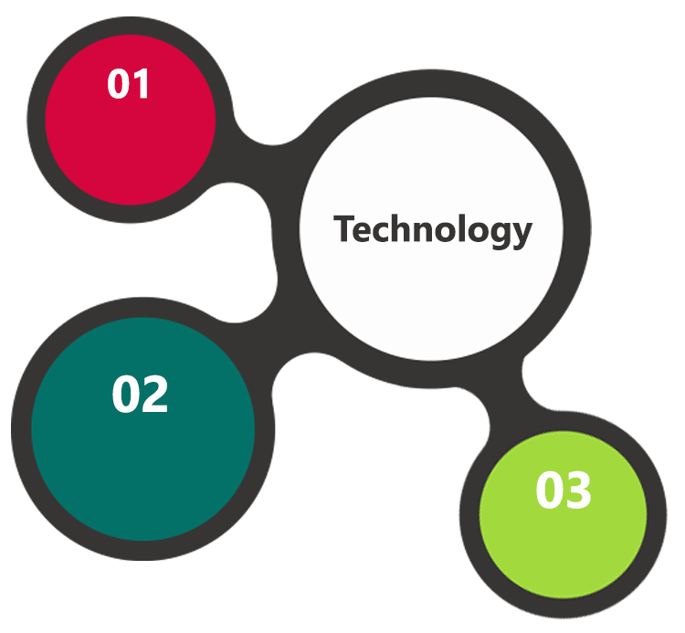

ASP.Net, MVC

, Android SDK

HTML5 / CSS3

Java Script

Windows

IIS

MS SQL

Android

**MS SQL2012  
Windows 8/10  
Web Services**

## TECHNICAL CONFIGURATIONS

### **DEVELOPMENT TOOLS**

* ASP.Net 4.5 /Android Studio/Java
* MS SQL
* HTML / CSS 3
* Photoshop
* Web services, Ajax, JavaScript

### **RECOMMENDED WEB HOSTING PACKAGE- DEDICATED HOSTING**

* Operating System : Windows Server
* CPU : 2 core
* Domains: Unlimited
* Disk Space: 200 GB
* Monthly Bandwidth: 50 GB
* Web site Server Software – IIS 7.5 +
* ASP.NET 4.5

### **BROWSER**

* Chrome version: 56

Firefox version: 51

Edge version: 39

### **HARDWARE**

The application is reliant on hardware interfaces to provide a seamless automated user experience.

* Android KitKat and above
* iOS 9.0 and above
* Computer with Windows 8 or 10 OS
* Compatible Browsers as specified in section 6.2.3

### **TECHNICAL STANDARDS**

* Screen Resolutions

*1080 x 1920, 720 x 1280, 750 x 1334, 640 x 1136*

* Testing Devices

*Google Pixel     Android 7*

*Motorola Moto G Turbo Edition -   Android 6*

*iPhone 5s, iPhone 6, iPad*

* OS Version

*Android KitKat and above*

### **TECHNICAL GUIDELINES**

The guidelines provide instructions and conditions that will be adhered to during the development of the mobile application.

* API will be used, as the case may be, in realizing the features and functionalities mentioned
* The client will finalize the functional requirements and UI/UX before the commencement of the project
* Verbat will be testing the app in the mentioned devices only. Testing on devices other than the ones mentioned under the “Technical Standards “ will have to be specified and provided by the client at the beginning of the development phase
* The client will have to provide the details of the testing devices they are using before the start of development phase
* Client should provide the relevant Developer's Account credentials before the development phase. In case Verbat needs to create the developer id additional charges will be incurred by the client
* The duration mentioned in the project time line is for development and testing and any delay or time taken by the review team to respond will not be Verbat’s responsibility
* Any clarification required from client needs to be addressed within 24 hrs.
* The apps will be developed / created within the guidelines of Android play and Apple store.
* Verbat will strictly follow the guidelines provided by the respective stores.
* Verbat will inform the client if any of the client requirements / request deviates from it.
* Customization of the features of the app will be susceptible to the limitation imposed by the respective platform/ store.
* Once development commences the test device/screen sizes will not be susceptible to change. Any change requested by the client will have to go through change management
* OS version support will be limited to the ones mentioned in the technical specifications. Further support will have to go through change management

## PROJECT DELIVERY

### **PROJECT MANAGEMENT**

The Verbat development center strictly follows industry standards on quality. The project management is process governed by the Verbat Quality Management system and is put to verification through internal audit programs that happen from time to time. Verbat will dedicate a project manager for the proposed implementation. Verbat proposes Client to identify one project manager who will be driving activities to be undertaken by Client to be the single point of contact for Verbat.

### **ROLES & RESPONSIBILITIES**

Verbat will assign a dedicated Project Manager/Project Lead to lead the project, who will be the first point contact for Client. He/she will be responsible for planning and managing the various activities within the project. He/she will work closely with Client Project Manager, to give periodic status updates and ensure high level of visibility and comfort on the progress of the project. The Project Manager/Project Lead will lead the co-ordination between Verbat and Client, thus enabling smooth transitioning of Client requirements to the Verbat ’ offshore delivery team, and provide visibility as well as comfort on the progress of the services to Client.

He/she will have periodic meetings with Verbat ’s Senior Management, thus ensuring Verbat ’ Management commitment and focus on Client initiatives.

### **DELIVERY ACTIVITY SUMMARY**

|  |  |
| --- | --- |
| Activities | Description |
| Detailed requirement Analysis | Verbat team to conduct detailed study of requirement for the phase. If clarification is required, team will reach out to Client for more information and/or time for discussions. |
| DB Design | DB design for central and test DB. |
| Software Requirement Specification document (SRS) | Once the requirement analysis is completed, Verbat team will submit the SRS document for approval |
| UI/UX Design, Prototyping | Based on the SRS, Verbat UX/UI team will work on the UI/UX of the screens and submit for approval |
| Functional Specification Document (FS) | Once the UI/UX is approved, Verbat shall submit an FS document for approval. |
| Development | Actual system development starts based on the FS. This involves detailed design and software development of Web Application. |
| Testing | Test Planning, test plan creations, internal, integration testing and user acceptance testing. |
| Deployment | Deploying the latest built in the Verbat Test Server. |

### **PROJECT IMPLEMENTATION PLAN**

Verbat will be providing the solution in a stand-alone fixed bid approach which ensures minimum viable solution for quick wins with core focus on the long-term business objective and outcome. Once the implementation is over, Verbat will initiate the application maintenance process (once the maintenance contract is signed) which continues to extend after the implementation.

### **DELIVERABLES**

* Project Plan
* Software Requirement Specification Document (SRS)
* UI/UX Design
* Functional Specification
* Fully Developed & Tested Application
* Documentations related to System Architecture, Database schema & Database backup
* Source Code

### **ESTIMATED DELIVERY TIME**

The effort estimated for delivering the application will be as below:

* XX (XX) UAE working days for the UI/UX from the date of approval of the SRS
* XX (XX) UAE working days for the development of the application from the Date of Approval of the FS.

| **Activity** |
| --- |
| Contract Signoff (T0) |
| Project Initiation & Initiating requirement gathering |
| Software Requirement Specification Document(SRS) |
| SRS Approval (T1) |
| System UI/UX-Complete |
| System UI/UX-Approval (T2) |
| Functional Specification (FS) |
| FS Approval (T3) |
| Development Phase-Complete |
| Perform QC (Unit Testing and Integration Testing) |
| System ready for UAT |
| UAT Acceptance on Verbat server (T4) |

* The above-mentioned timeline is in UAE Working Days
* The initiation of the UI/UX development is dependent on the confirmation of SRS. SRS will be submitted post the confirmation of the project along with LPO, signed proposal and advance payment
* The above mentioned timeline for development is post the confirmation of FS
* Documentation submitted after project initiation and system study supersedes any proposal or documentation submitted during initial requirement gathering / discussion / negotiation
* Project plan will be submitted post the confirmation of project with necessary payments
* Any delay in getting the approvals of deliverables from client will cause change in timelines and the revised timelines will be updated in weekly status reports shared with client after the project commencement
* All approvals and queries regarding the client requirement and any queries which may hinder the project advancement at any stage should be answered by the client within 24 hours from the time of initiation, failing which the time delay will get added to the actual effort and timeline which was estimated.
* On project confirmation, Verbat requires a lead time of minimum seven (07) days for resource mobilization.

### **DEPLOYMENT DETAILS (AT CLIENT’S BEHEST)**

* Client can opt for hosting the application at Verbat’ Server.
* If deployment is at the client’s server, responsibility of deploying the application onto the production environment after conducting the necessary acceptance testing will lie with the client unless and until Verbat ’ support is contracted for deployment.

*Note:*

*Refer “Windows Hosting Proposal” for the charges related to Hosting the application on Verbat’ s Server.*

### **RELEASE PLANNING**

* Client will be informed about the release date and time through email.
* Client performs the UAT

### **RISK CONTINGENCY PLANNING**

Verbat has identified various risk factors associated with this assignment and understands the impact of these risk factors on the project schedules. The objective of this section is to highlight for both Verbat and client, the risk factors, to analyze the impact of the risks on project execution, and to propose strategies to control and reduce the impact of the risk factor. These various risks, which could arise during the project, are tabulated below along with mitigation implementation.

| Type of risk | Impact | Risk Mitigation | Risk Handling |
| --- | --- | --- | --- |
| Scope Creep | H | Functions and features will be detailed in system requirement documents and will go through client approval. Once this document is approved, any change to requirement will go through change management review for possible impact assessment. | Proper change management procedure will be implemented. |
| Delay in customer feedback | H | The plan is prepared with enough lead-time for customer reviews and approvals.  The customer is indicated with the dates when the document is expected after review and approval. | The request for feedback will be escalated if not attended at the right time so that the schedules are not affected. Deemed acceptance criterion is set up front and will be followed. |
| Non-availability of necessary software’s, frameworks, database instances and infrastructure at client’s hosting environment(If hosting support is provided by Verbat ) | M | Client will be informed in advance on these requirements. | Possible impact to schedule. |
| Manpower attrition | L | All efforts would be made to ensure process dependence rather than being person dependent. As a risk mitigation plan Verbat will train backups. | A new person will be identified as early as possible, provided the required project-specific training and mentored by the senior members of the team to minimise impact of attrition on the project. |

*H-High, M-Medium, L-Low, NA-Not Applicable*

## PROJECT ASSUMPTIONS

The project solution and technology is created from the initial understanding of the requirement shared with Verbat through mails and meetings. The proposed solution is based on the following assumptions:

### **OBJECTIVE**

* The requirement is to develop a Ministry of Justice website & mobile application with the functionalities as defined in ‘Functional Requirements’ section

### **DESIGN**

* Client to provide Verbat with the branding guidelines.
* Color theme shall be provided by the client
* Client shall provide licensed images and logos in specified size & format
* Client shall provide the text and associated images for the proposed application. Text should be provided in digital format preferably in MS Word 2013 or above
* Verbat may use template based design for the application
* The application designed for mobiles will be in portrait mode

### **DEVELOPMENT**

* The proposed application front end and backend would be developed in English & Arabic
* Development Contingent upon timely feedback from client
* The client will finalize the functional requirements and UI/UX before the commencement of the development of the project
* Client shall approve the UI/UX for the mobile and web application before development work starts
* Verbat assumes client requires minimal reports and the reports considered in the scope are mentioned under the respective user modules.
* The following items will be hardcoded / implemented in the application
* Final data needs to be entered by the client via the application
* Client will provide sample data to test the application
* Testing of web application will be done in latest versions of Google Chrome, Mozilla, Edge web browsers only
* Testing of the mobile app will be executed on devices mentioned under Technical Standards
* Client will procure templates, SSL certificates (if applicable)
* Client will host and manage the application on infrastructure (server / cloud) recommended by Verbat for managing database and application backup inclusive of images
* Application and data backups are subject to the purchase of such services at an extra cost
* Internet connectivity is required for the functioning of the Mobile App & Web portal
* Mobile Application elements or design cannot be modified once the app is deployed
* This estimate is only for portrait orientation on mobile phones
* Supporting OS: Android SDK V 19 (KitKat) and above.
* Client shall provide the developer account for Android & Apple Store.
* Does not support offline access or operations.
* Website shall be creatively designed, easy to navigate, follow TRA guidelines for government websites

# **OUT OF SCOPE.**

With the ever evolving digital market, the requirement should be clear to both the parties involved, hence the importance of mentioning the out of scope details of the project. Following are considered to be out of scope while creating this proposal:

* Purchase of images, fonts
* Any language other than English & Arabic
* Content or image procurement or uploading or editing
* Audit Trail
* End user testing and load testing
* Developer account creation and Maintenance (Play Store)
* Adding new features to the application other than mentioned in the functional specifications. Such requests will be handled via change management. *For Change management details, please refer section titled “Change Management” in the Proposal*. (refer to section 4.1)
* Annual Maintenance Contract (Bug fixing, debugging, enhancements) – Please refer section titled “Maintenance and Support”, unless contracted for.(refer to section 4.2)
* Hosting Infrastructure and Maintenance (web and email hosting), unless contracted for.
* Application Deployment on the server and respective stores, unless contracted for.
* Backup solution and Disaster recovery unless contracted for.
* Physical deployment onsite / installation of the application in devices and Physical connection, installation of system.
* Integration with third-party, if any, other than mentioned in the functional specifications
* Hardware Integrations / procurement and purchase
* Procurement of SMS gateway / payment gateway / email gateway
* Integration of SMS gateway / payment gateway
* SSL Purchase and installation, if any
* Plugin/template purchases, if any
* OS other than mentioned in the Hardware Interface
* Relevant / related software libraries
* Mobile offline access or operations

## CHANGE MANAGEMENT

Any addition which comes out of the project scope, upon and after the launch of the application will be considered as change management. Verbat recommends the following change management procedure for the same.

* Any change which comes out of the project scope, which was discussed, documented, and mutually approved by both the parties in the requirement stage, will be carried out only through raising a change request.
* Change request will be studied and an impact analysis on the existing work flow will be performed.
* On finalizing the impact, effort estimation for the change will be calculated and raised as additional requirement.
* Verbat will initiate the change request only after getting a formal approval from the client for the additional changes raised.
* Any change from the scope will be charged at AED 1,200.00 per man day effort and approval from the clients will be availed before commencing on any change management.

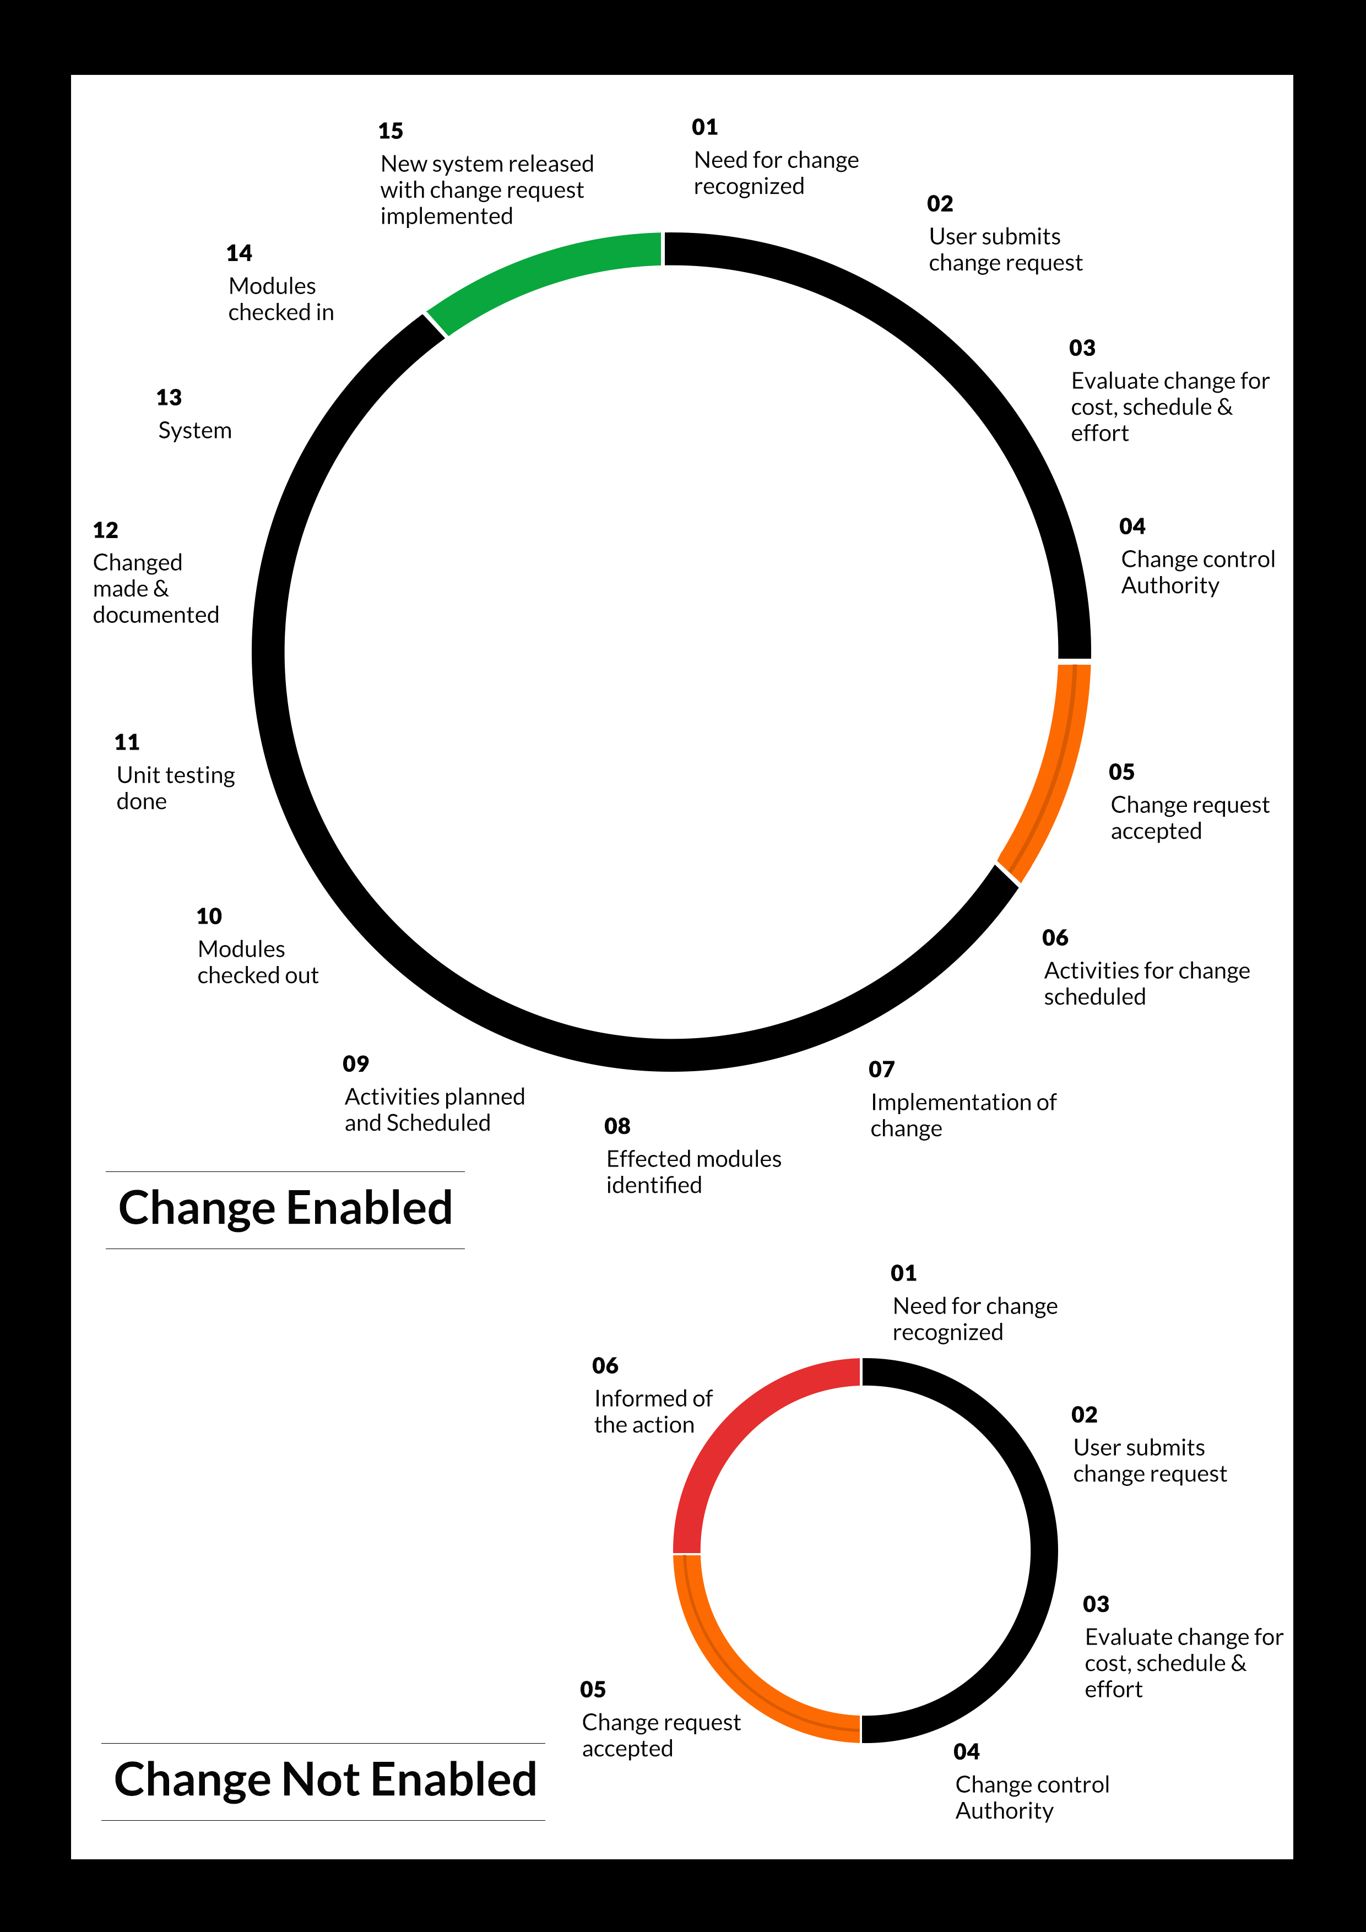

## MAINTENANCE & SUPPORT

* Maintenance contracts by default are supported as per the basic SLA terms.
* AMC with Basic SLA is charged at 25 % of the total project value. Additional Effort/change management request will be added towards Total Value of the Project to determine the AMC value.
* Maintenance support is limited to providing application support for ensuring the consistency of the look-and-feel, bug fixes and user issues i.e. maintenance and support of the existing features of the application.
* Support does not in any way cover providing technical or other support to the end users. The maintenance agreement does not include functionality changes or feature additions which are handled as change requests which will be charged AED 1,200.00 per man day. AMC does not include server support, maintenance and application deployment.
* AMC charges will cover Off-Site Support and Debugging. Support includes E-mail, Telephone and Chat unless explicitly specified. In the event, the application is hosted with the client; necessary remote desktop connectivity should beprovided for carrying out maintenance activity.
* Gap in AMC - In case if the client does not opt an AMC for a year and want to renew it after that period, 50% of the AMC amount for the year for which AMC is not taken will also be payable if the client wishes to renew the AMC contract.

*Note:*

* *Please note that the AMC support shall start only after all the necessary sign-offs (AMC Document) to this effect have been given.*
* *It is not mandatory that the client should opt for an AMC (replace with perhaps: It is mandatory that the client opts for an AMC). The client will still be supported on an ad-hoc basis on an agreed man-day rate.*
* *AMC Payment Terms: 100% to be paid as advance.*

## SERVICE LEVEL AGREEMENT (SLA)

|  |  |  |  |  |
| --- | --- | --- | --- | --- |
| **SLA Type** | **Max Response Time** | | **Max Resolution Time** | **Target** |
| Basic | 1  working day | 3 working days | | Request / incident / problem tickets |
| Advanced | 5 Business Hours | 12 Business Hours | | Request / incident / problem tickets |
| Priority | 3 Business Hours | 5 Business Hours | | Request / incident / problem tickets |

*Note:*

* *We provide Basic SLA as standard with AMC while Advanced and Priority SLAs attract additional charges.*
* *Time zone applicable (8:00 am to 5.00 pm, Sunday to Thursday)*

AMC Option:

Client can opt for time and material based Annual Maintenance, the details of which will be shared post the completion of project.

# **TERMS & CONDITIONS.**

## ACCEPTANCE CRITERIA

* UAT (User Acceptance Test) sign off should happen within 07 Days from the first release of the application and the acceptance confirmation needs to be mailed to Verbat failing which Verbat will consider the project as approved by the client.
* Any comments or reason for rejection need to be documented and the same needs to be sent as an email from the official mail id of client to Verbat on or before 07 days from the first release.
* Timeframe for acceptance for any further release will be mutually agreed and finalized between client and Verbat depending on the UAT Comments

## WARRANTY

* Verbat shall provide a bug ﬁx warranty at no additional cost for 30 days from the date of acceptance of the project, for correction of any errors in the developed application that may be attributed to Verbat.
* However, this does not cover modifications by Client, or use of the application on an environment other than the proposed environment, or other circumstances outside Verbat’s reasonable control. In such a case Verbat reserves the right to charge for its services.
* All error corrections will be executed at Verbat India office. In the event of any need for on-site work, all expenses incurred for such trips will be payable to Verbat by Client.

## SOURCE CODE & INTELLECTUAL PROPERTY RIGHTS

* Upon completion of the Project and 100% completion of the payment, client will have access to the source code except for propriety codes, developer tools and third party applications etc.
* The solution offered will be the intellectual property of the client and will be made available to the client on an “unlimited license” basis.
* Modifications by third party/person: No person or organization, other than Verbat or any person authorized by Verbat in writing, has any permission to modify/change the software Solution to be eligible to get continued support from Verbat as per the support terms defined under this document.
* Liabilities/Damages: Verbat accepts no liability or damages of any kind arising out of use or non-use of the software delivered. The responsibility of testing of software lies with Client.

## GENERAL TERMS AND CONDITIONS

* Offer Valid for 30 calendar days from the date of submission of the Proposal.
* An average of 20 working days are assumed in a month.
* All the projects activities will be carried out from our off-shore development center in India
* All the documentation will be provided in English.
* Third party components may be used to develop this application.
* The scope of the project is to develop the Application as detailed in the scope of the project and mentioned in this proposal. Any changes or additions will have to go through change management.
* This proposal would have been derived or concluded from either the RFQ /RFP/data shared via email / information transferred during an initial requirement analysis meeting / tele-conversation. Verbat reserves the right to change the terms of this proposal as the final terms (including the costing), features & functionalities and timeline could change during the course of the project. Hence any fees quoted / timeline committed in this proposal may not be considered as final unless agreed and signed by both parties.
* Web Application will be best viewed only in the environment mentioned in the section Browser Compatibility
* Mobile app will be best viewed only in the environment mentioned in the section Hardware Interface
* All Source Codes and other project artefacts would adhere to the Verbat document templates and internal coding standards.
* The documents delivered to the client includes the ones mentioned under ‘Deliverables’ and these will adhere to Verbat’s internal document standards.
* Acceptance criteria shall be based on the clauses which were mutually discussed between Verbat and client at the Requirement Analysis phase and the same will be documented and approved by both parties through official emails
* In case Client requires any extension of the proposed acceptance schedule, the associated effort and cost of such extension can be mutually reviewed.
* For any circumstances if project needs to be put on Hold / Stop it requires minimum request notice period of 1 week along with duration for which request will be addressed by management and final decision on the request will be based on that
* If deployment is done in client’s server, Verbat cannot be held responsible for any performance issues arising due to hardware malfunctions.
* Client is responsible for data backup in case the application is not hosted on Verbat server.
* Source code will only be delivered or uploaded on the Production Server once the due payments are made.

## GENERAL ADMINISTRATIVE, TECHNICAL & FUNCTIONAL ASSUMPTIONS

* Detailed system study is required before the start of the project.
* During the requirement gathering phase, authorized personnel from the Client’s side is expected to be available for discussion and finalizing the HLD (High Level Design), before development commences.
* Type of reports and formats, if under the scope of the project, needs to be specified by Client before project sign off.
* Workflows if under the scope of the project, need to be specified/ confirmed by client before project signoff.
* Verbat assumes that all sign-offs from Client will be provided within agreed and specified timeframe.
* Client will provide all the necessary contents, both text and image, before starting the project in the format suggested by Verbat (if any).
* The client should provide the relevant information and data well in time for the execution of a related activity. Non- availability of this information or data may lead to an interruption of work which may result in a delay in delivery as well as additional costs to the client.
* Client should have/possess server with technical specifications as suggested by Verbat for the proposed application.
* Client will be provided with one time training (train the trainer) on how to use the application via video conference (maximum of 4 hours). Additional training requests will be charged.

# **FINANCIALS.**

## WEB AND MOBILE APPLICATION DEVELOPMENT

|  |  |  |
| --- | --- | --- |
| **No** | **Description** | **Amount (AED)** |
| 01. | Development of:   * Web Application for admin and Viewer * Android Mobile Application users * Integration for user authentication |  |
|  | **Total Project Cost** |  |

*Note:*

* *The above cost is exclusive of VAT applicable in UAE*
* *The above cost is based on the initial understanding of the requirement grounded on the details shared by client. Any further changes in the scope or complexity if encountered during detailed system study/ analysis will call in for additional effort and time.*
* *The above cost does not include Application hosting, integration with any other third-party systems, deployment unless explicitly mentioned in this proposal.*
* *For feature additions, please refer section titled “Change Management “.*
* *LPO to be raised in the name of “Verbanet Technologies LLC” for project initiation*
* *Refer section 7.3 for ‘Mode of Payment’.*

### **PAYMENT TERMS**

* 30% () of total project value to be paid as advance along with the Purchase Order
* 40% () of total project value to be paid on confirmation of the UI/UX
* 30% () of the total project value to be paid on completion of Development and UAT on Verbat test server

*Note:*

*Payment should be made within 7 days from the date of invoice.*

## WINDOWS DEDICATED HOSTING – OPTIONAL

ITEM NO. DECSRIPTION AMOUNT (AED)

1. Windows Dedicated Hosting

TOTAL PROJECT COST

*Note:*

* *The above cost is exclusive of VAT applicable in UAE*
* *Refer “Windows Dedicated Hosting Proposal” for detailed Server specifications.*
* *Refer section 7.3 for ‘Mode of Payment’.*
* *LPO to be raised in the name of “Verbanet Technologies LLC” for project initiation*

### **PAYMENT TERMS**

* 100% advance payment along with Purchase Order to initiate Server purchase

*Note:*

Payment should be made *within 7 days from the date of invoice.*

### **MODE OF PAYMENT**

By Cheque to Verbanet Technologies LLC

OR

Wire transfer to our bank account

Bank Name : Emirates NBD

Account Name : Verbanet Technologies LLC

Account Number : 1011492858201

IBAN Number : AE61 0260 0010 1149 2858 201

Swift Code : EBILAEAD

Bank Address : Mamzar Branch, Dubai

*Note:*

* *Bank charges incurred during wire transfer to be borne by the client.*
* *Any local taxes / VAT applicable to be borne by the client*
* *Client invoices will include VAT charges in addition to the application cost*

# **ABOUT US.**

Education

Transportation

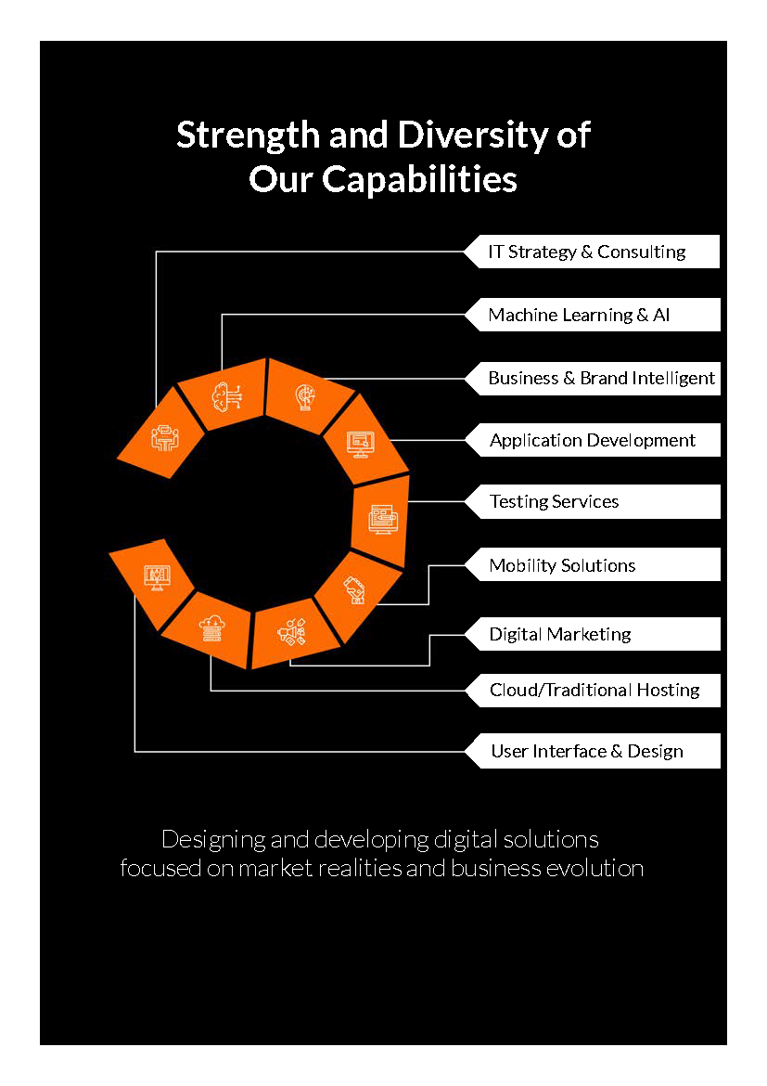



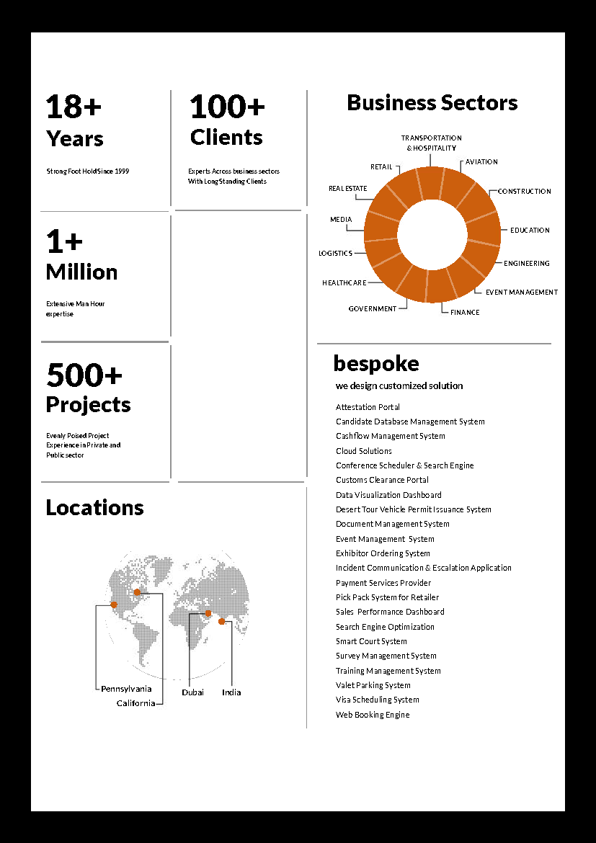

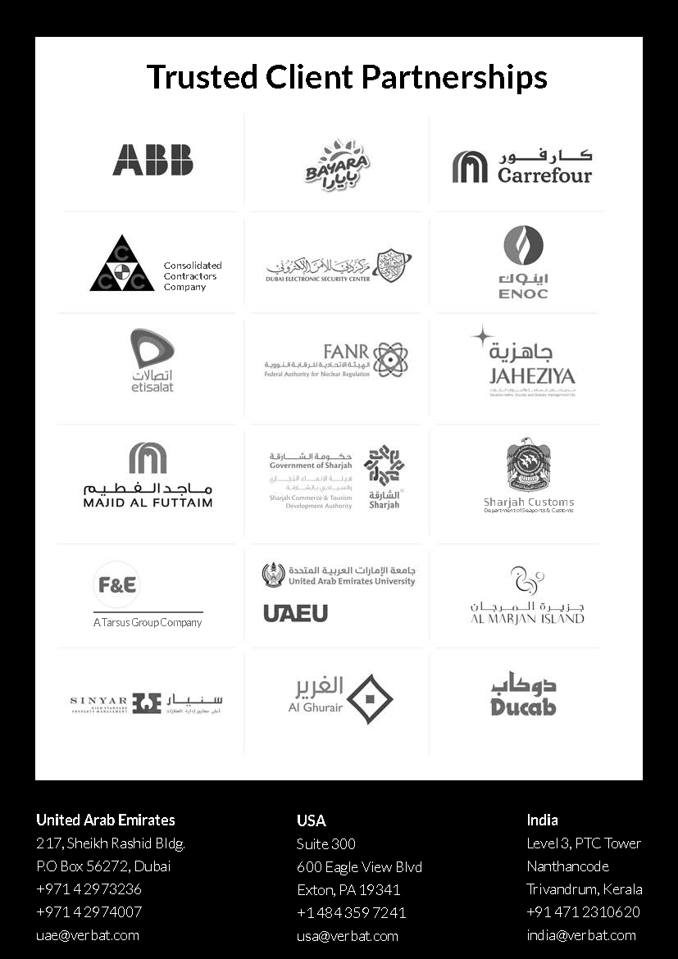

**Conﬁdentiality Notice:**

**This Proposal is conﬁdential and contains proprietary information and intellectual property of Verbanet Technologies LLC. Neither this proposal nor any of the information contained herein may be reproduced or disclosed under any circumstances without the express written permission of Verbanet Technologies L.L.C (hereby known under its brand name of Verbat in the United Arab Emirates). 2018. All rights Reserved**